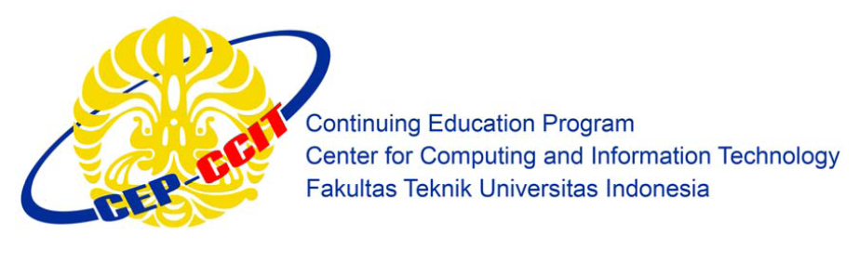

**PROJECT**

**“DIGITAL CLOCK ON PROTEUS”**

Written by :

* David Julian Ernestine (2120010033)
* Isaac Gideon Simamora (2120010068)
* Muhammad Rafi Aulia (2120010095)

Class : 2ISA2

Faculty : Mr. Idham Khalif,S.Kom

**Continuing Education Program Center for Computing and Information Technology**

**Faculty of Engineering, University of Indonesia**

**2022**

**PROJECT ON**

**Digital Clock**

**Developed by:**

1. David Julian Ernestine
2. Isaac Gideon Simamora
3. Muhammad Rafi Aulia



**Analyze Data of Digital Clock**

Batch Code : 2ISA2

Start Date : May 19th, 2022

End Date : May 25rd, 2022

Date of Submission : May 25rd, 2022

Name of Coordinator : M. Idham Khalif,S.Kom

Names of Developer :

* David Julian Ernestine
* Isaac Gideon Simamora
* Muhammad Rafi Aulia





**CERTIFICATE**

* This is to certify that this report, titled ***“*DIGITAL CLOCK*”***, embodies the original work done by David Julian Ernestine, Isaac Gideon Simamora and Muhammad Rafi Aulia inpartial fulfillment of his course Requirement at NIIT.

Coordinator : M. Idham Khalif,S.Kom

**ACKNOWLEDGMENT**

Praise God Almighty, for the presence of plenty of mercy and his grace, so that we can complete this project with the title "DIGITAL CLOCK ON PROTEUS". Without His mercy we would not be able to complete this project in time. Even though there are many obstacles that we face on making this project, but finally we can finish this project.

We have benefited a lot from the feedback and suggestions given to us by Mr. Idham khalif,S.Kom

**SYSTEM ANALYSIS**

**System Summary :**

Technology is evolving very fast. All this is basically for the satisfaction of the people in the world. Over time, people will be busy with their own activities. One useful component is Proteus, which is very useful in the design of microcontrollers. Proteus is also useful for learning electronics, from the basics of electronics to microcontroller applications. This software offers a number of sample applications for users to learn. The development of technology has the distinct advantage of making every job easier, from teenagers to students.

The purpose of our calculations with a combination of a combination of serial and parallel circuits is to discuss. Digital clocks are usually also available in electrical circuits. Digital Clock Makes it easier for users to view the clock digitally, eliminating the need to look at the clock in exactly the same direction.

**PROTEUS DESIGN**

**Proteus Name :** Digital clock

**Component Name :** 1. LED

2. Switch

3. IC 74192

4. TTL IC 7408

5. Ground

6. TTL IC 7404

7. LED-BCD

* LED can be defined as an electronic component made of semiconductor material and can emit light when an electric current passes through it.Led (Ligth-Emitting Diode) has the main function in the world of electronics as an indicator or indicator signal / indicator light.

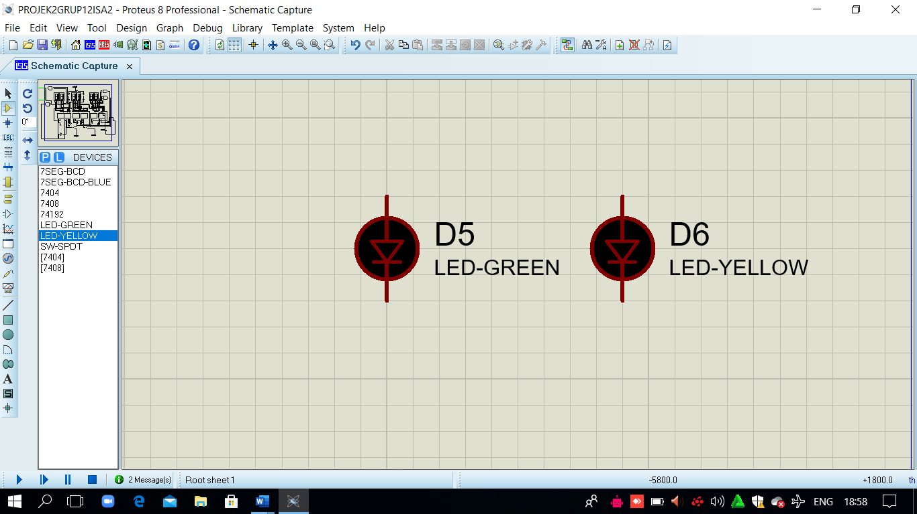

* Switch Is a device with two connections and can have two states, namely the On state and the Off state. Off (close) is a condition where there is no current flowing. The On (open) state is a state in which current can flow freely or in other words (ideally) there is no resistivity and the voltage at the switch is zero. And close the circuit when pressed, or precisely open the circuit when pressed. If the pressure is released or the next pressure occurs, it will normalize the button back to its original position and the circuit returns to its original state.

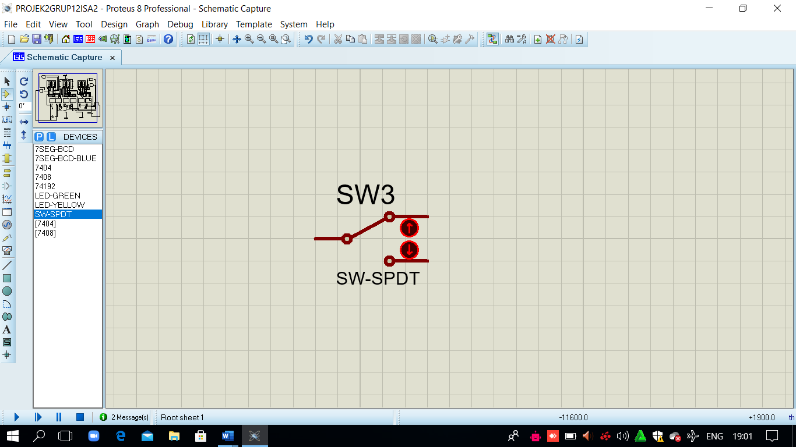

* IC 74192 is if 192 it will only count binary values ​​for decades or from 0000 to 1001 in binary or 0 to 9 in decimal, in other words this ic is a modulo 10 counter.

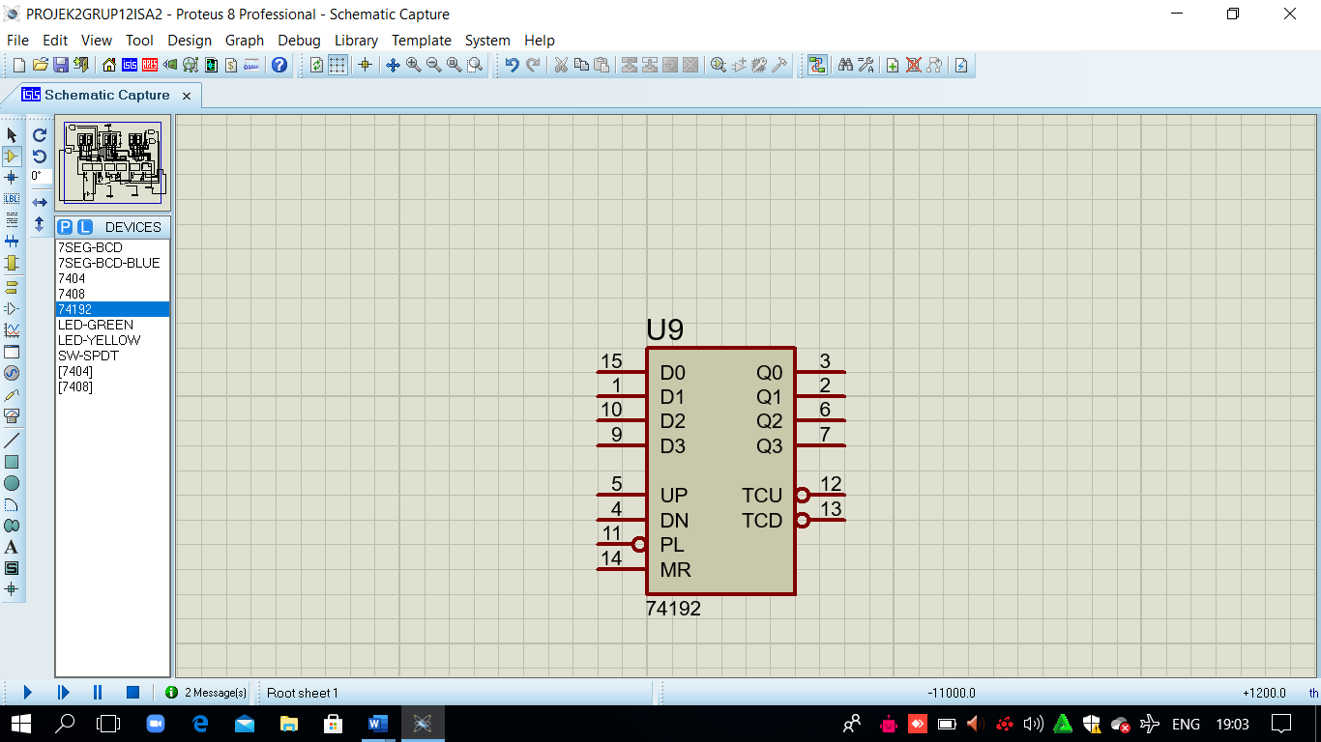

**COMPONENTS**

**COMPONENTS**

* TTL IC is an IC that is widely used in digital circuits because it uses a voltage source (VS) between 4.75 volts to 5.25 volts. The building component of TTL ICs (logic transistors) is as the name implies. This IC contains several transistors that are combined to form two states (ON /OFF).

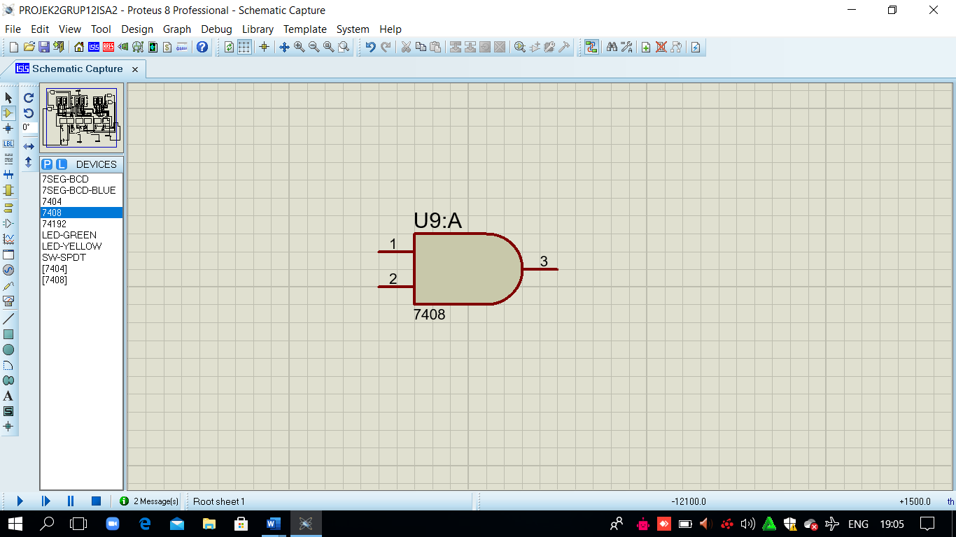

* Ground = Ground or land is a security system in electrical installations where in the event of a power leak, electricity will flow directly to the ground so as not to injure the user.The function of the ground is very important where the ground serves as a safety in the event of a leakage of electricity and this is often ignored.

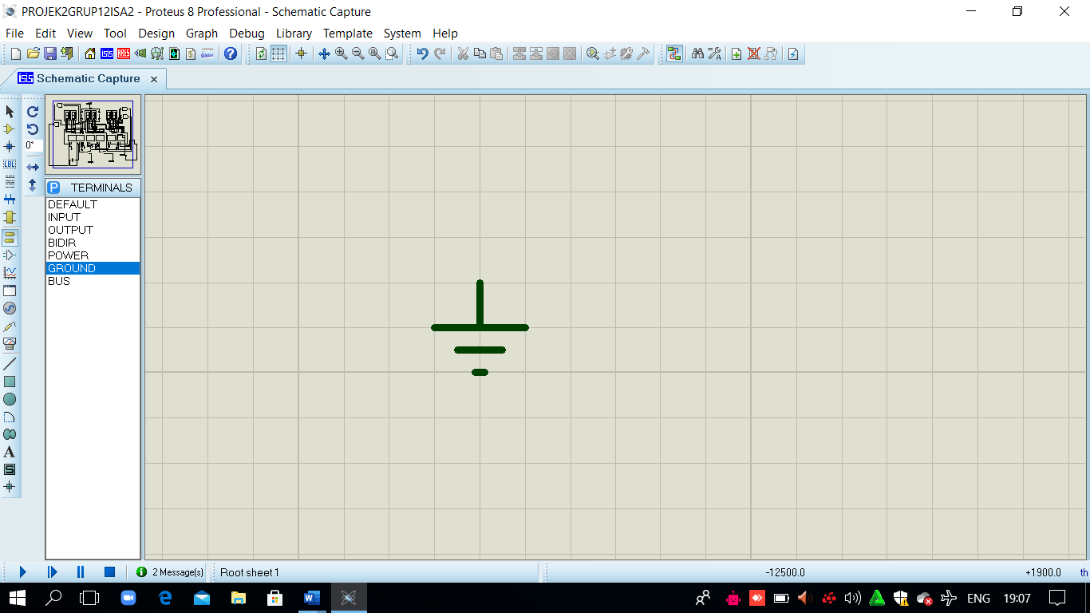

* TTL IC is an IC that is widely used in digital circuits because it uses a voltage source (VS) between 4.75 volts to 5.25 volts. The building component of TTL ICs (logic transistors) is as the name implies. This IC contains several transistors that are combined to form two states (ON / OFF).

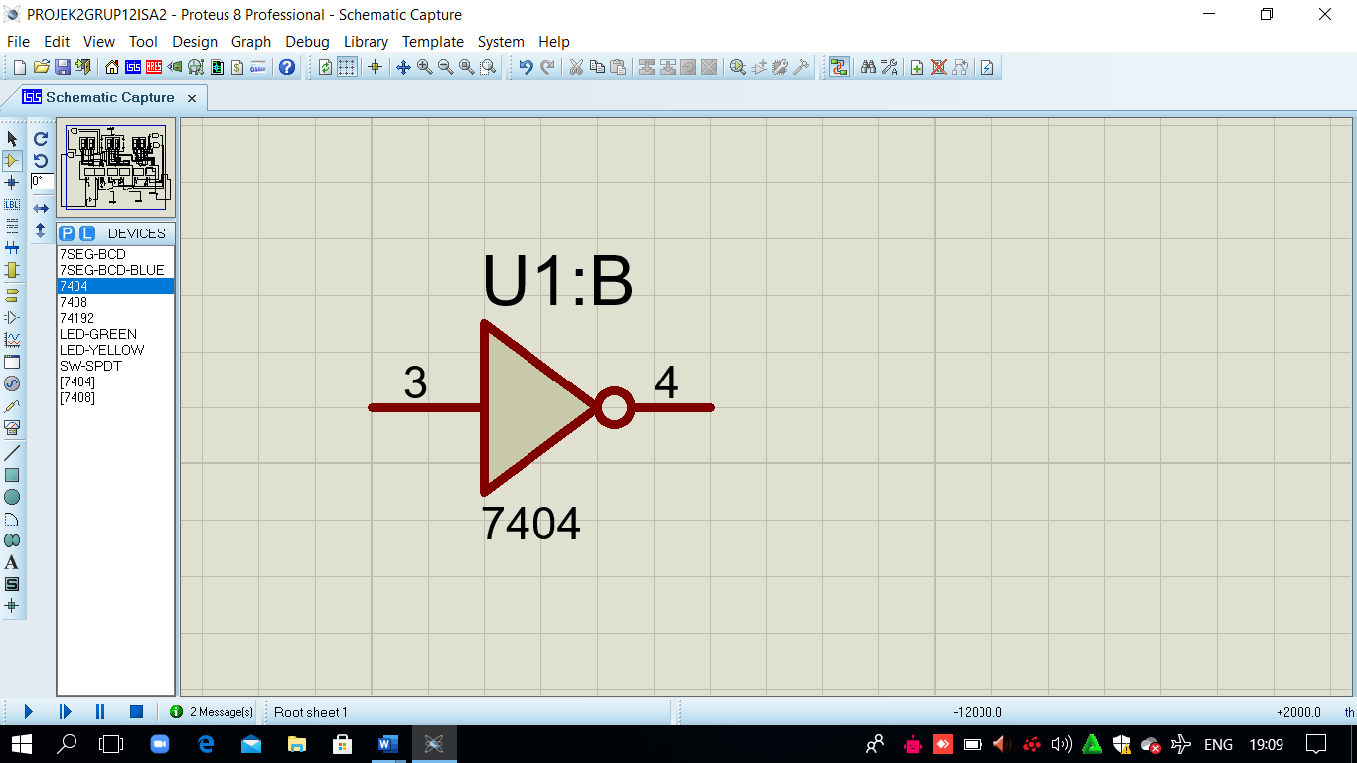

**COMPONENTS**

* LED BCD can be defined as an electronic component made of semiconductor material and can emit light when an electric current passes through it. Led (Ligth-Emitting Diode) has the main function in the world of electronics as an indicator or indicator signal / indicator light.

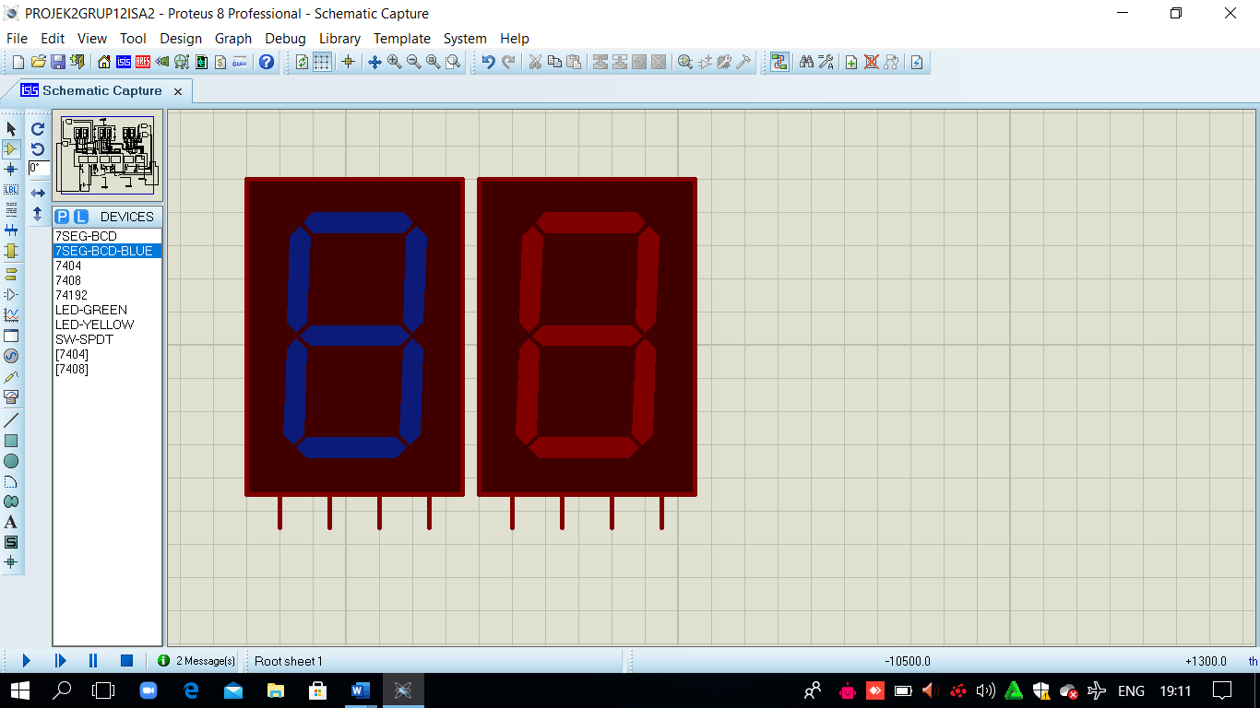

**ANALYSIS OF DIGITAL CLOCK**

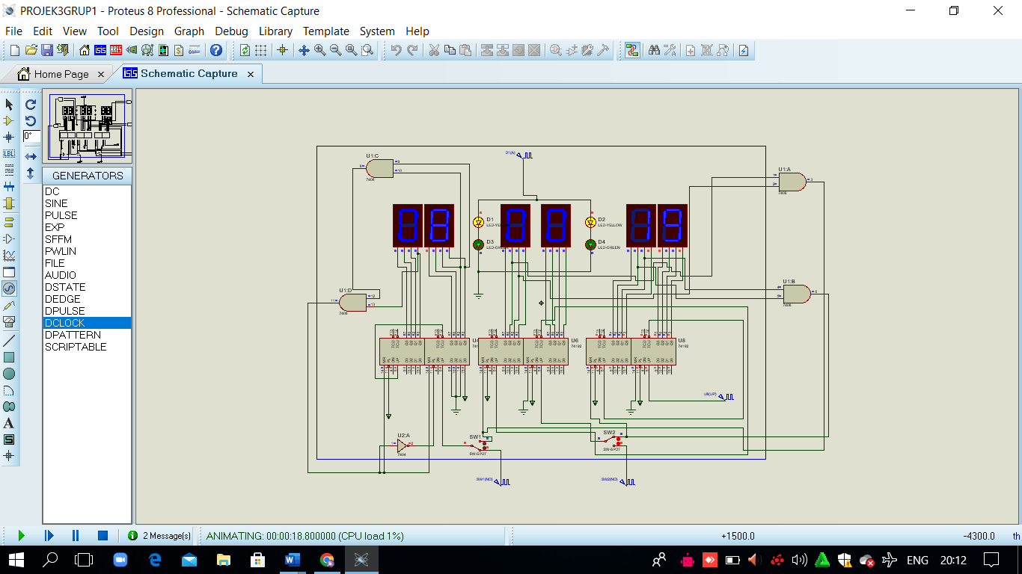

This series consists of six 7 segments, the use of 7 segments is to display a number display, which is divided into 3 parts of hours, minutes and seconds. From each part it has been connected to the 74192 ic counter up, which amounts to 6 pieces.

On the display 7 segment seconds, the maximum number that is displayed is 59, after 59 he will return to the number 00, because the pin of the 7 segment is currently connected to pin ic 74 192 corresponding to binary code decimal in pin.

And on the minute part of the 7 segment display, the maximum number displayed is the same as the second, which is 59 and after 59 it will return to 00, and for the 7 segment display in the hour section the maximum number displayed is 12 because or there are only 12 hours on the 7 segment display.

**ANALYSIS OF DIGITAL CLOCK**



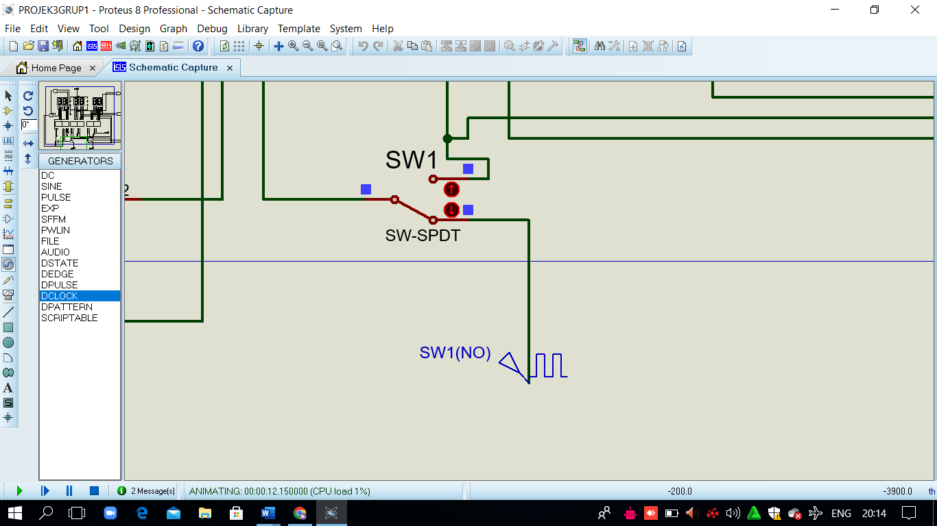

The switch is clicked to set the numeric display on the clock or the leftmost 2-digit part.

**ANALYSIS OF DIGITAL CLOCK**



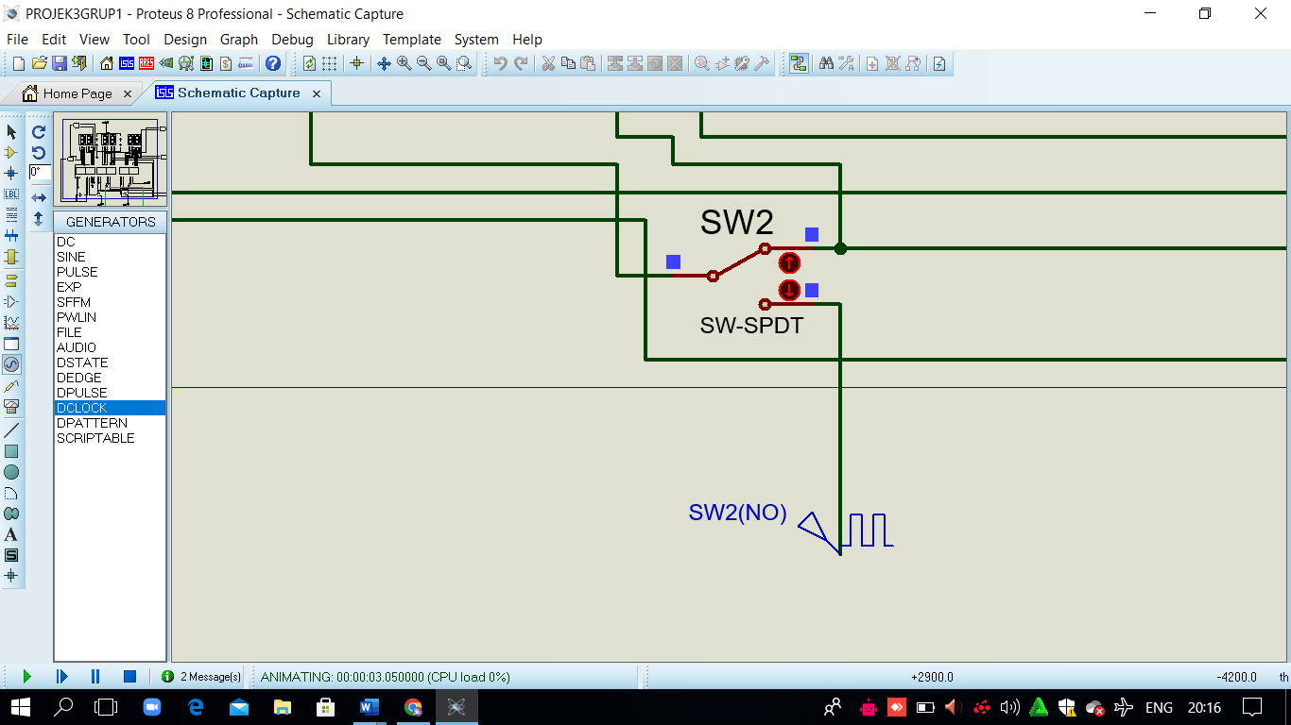

And the next button clicked is to set the display of numbers in the minutes or 2 numbers in the middle.

**CONFIGURATION**

**Operating System :** Windows 10

**Hardware :** Laptop

**Software :** Proteus 8 Proffesional (Schematic Capture)

Microsoft Word 2021 (Project Report)

|  |  |  |
| --- | --- | --- |
|  | **PROJECT FILE DETAILS** |  |
| **NO** | **FILE NAME** | **Remarks** |
| 1 | PROJEK3GRUP1.pdsprj | David Julian Ernestine  Isaac GIdeon Simamora  Muhammad Rafi Aulia |
| 2 | Project 3 2 ISA 2 PROTEUS.docx | David Julian Ernestine  Isaac Gideon Simamora  Muhammad Rafi Aulia |
| 3 | PROJEK 3 GRUP 1 2ISA2.pptx | David Julian Ernestine  Isaac Gideon Simamora  Muhammad Rafi Aulia |